Tasmanian Acute Public Hospitals
Healthcare Associated Infection Surveillance Report 35 – Quarter 3 2017
Tasmanian Acute public Hospital Healthcare Associated Infection Surveillance Report 35 – Quarter 3 2017
Department of Health and Human Services, Tasmania
Published 2017
Copyright—Department of Health and Human Services
Permission to copy is granted provided the source is acknowledged
Authors
- Ms Fiona Wilson, Clinical Nurse Consultant, TIPCU
- Dr Tara Anderson, Specialist Medical Advisor, TIPCU
- Ms Anne Wells, Assistant Director of Nursing, TIPCU
Suggested reference: Wilson, F., Anderson, T., Wells, A. (2017). Tasmanian Acute Public Hospitals Healthcare Associated Infection Report No 35 – Quarter 3 2017. Hobart: Department of Health and Human Services.
Reviewed and approved by the Tasmanian Healthcare Associated Infection Advisory Committee and the Director of Public Health, DHHS Tasmania.
Notes
Data are subject to ongoing revision so data from previous reports should not be relied upon. Use the most up to date report when citing data.

Contents
Tasmanian Acute Public Hospitals 1
Contents 3
Index of figures and tables 4
Executive summary 5
Staphylococcus aureus bacteraemia 6
Tasmanian rates 6
Hospital rates 7
Clostridium difficile infection 8
Tasmanian rates 8
Hospital rates – by quarter 9
Vancomycin resistant enterococci 10
Carbapenemase-producing Enterobacteriaceae (CPE) 12
Hand Hygiene 13
Tasmanian rates 13
Acknowledgements 16
Appendix 1 17
Explanatory notes 17
Appendix 2 20
Healthcare associated Staphylococcus aureus bacteraemia (SAB) 20
Clostridium difficile infection (CDI) 25
Vancomycin resistant enterococci (VRE) 28
Hand hygiene compliance data October 2017 31

Index of figures and tables
Figure 1 Healthcare associated Staphylococcus aureus bacteraemia - Tasmanian rate by quarter 6
Figure 2 Healthcare associated Staphylococcus aureus bacteraemia - rate by quarter 7
Figure 3 Acute public hospital identified CDI and HCA-HCF CDI – rates by quarter 8
Figure 4 Hospital identified CDI by quarter 9
Figure 5 HCA-HCF CDI by quarter 9
Figure 6 First VRE isolates – classification by quarter 10
Figure 7 First VRE isolates - genotype by quarter 11
Figure 8 Hand hygiene compliance in Tasmanian public hospitals 13
Figure 9 Hand hygiene compliance by moment 14
Figure 10 Hand hygiene compliance by healthcare worker 15

Table 1 Healthcare worker categories 15
Table 2 Tasmanian numbers and rate per 10 000 patient days of HCA-SAB. 20
Table 3 Royal Hobart Hospital numbers and rates per10 000 patient days of HCA-SAB 21
Table 4 Launceston General Hospital numbers and rates per10 000 patient days of HCA-SAB 22
Table 5 Mersey Community Hospital numbers and rates per10 000 patient days of HCA-SAB 23
Table 6 North West Regional Hospital numbers and rates per10 000 patient days of HCA-SAB. 24
Table 7 Tasmanian numbers and rates per10 000 patient days of CDI 25
Table 8 Hospital numbers and rates per10 000 patient days of hospital identified CDI 26
Table 9 Hospital numbers and rates per10 000 patient days of HCA-HCF CDI 27
Table 10 First VRE isolates identified per quarter. 28
Table 11 Classification of first VRE isolates – colonisation and infection 29
Table 12 First VRE isolates by genotype by quarter 30
Table 13 Hand hygiene compliance rates by Tasmanian hospital and state level 31
Table 14 Tasmanian hand hygiene compliance rates by moment 32
Table 15 Tasmanian hand hygiene compliance rates by healthcare worker 32

Executive summary
This quarterly report provides an overview of the Tasmanian acute public hospitals’ healthcare associated infection surveillance for the third quarter (Q3) of 2017.
Details of the surveillance program, including the rationale for the indicators measured and the methodologies used in data collection, validation and analysis are available at the TIPCU website
Any form of comparison between hospitals should be done with caution because data are not adjusted for patient characteristics that vary between hospitals.
Further, the relatively small Tasmanian population and small number of events can result in volatility of rates from time to time.
The raw data in the appendices illustrate this.
This report contains the following findings:
- The rate of healthcare associated Staphylococcus aureus bacteraemia (SAB) remains low and below the National threshold.
- The rate of ‘hospital identified Clostridium difficile infection (CDI)’ and ‘hospital identified, healthcare associated-healthcare facility onset (HCA-HCF) CDI’ has remained stable.
- The number of new isolates of VRE has decreased this quarter for the first time in over a year.
- There were no cases of Carbapenemase producing Enterobacteriaceae (CPE) notified.
- The consolidated Tasmanian public hospital hand hygiene compliance rate is below the National Benchmark of 80 per cent.

Staphylococcus aureus bacteraemia
Staphylococcus aureus, a common cause of serious healthcare associated bloodstream infection (bacteraemia), may cause significant patient morbidity and mortality.
Many healthcare associated Staphylococcus aureus bacteraemias (SAB) are preventable. SAB was made notifiable in Tasmania in 2008 pursuant to the Public Health Act 1997. Tasmania was the first Australian jurisdiction to introduce this measure to capture SAB data.
SAB surveillance is carried out in Tasmania using the national surveillance definitions published by the Australian Commission on Safety and Quality in Health Care (ACSQHC).
Under this definition a SAB is defined as healthcare associated if the patient’s first SAB positive blood culture was collected either >48 hours after hospital admission or <48 hours after discharge (Criterion A) OR ≤48 hours after hospital admission and one of four key clinical healthcare related criteria was met (Criterion B).
The National Healthcare Agreement (2011) target is no more than two HCA SAB per10 000 patient days.

Tasmanian rates
Figure 1 and Figure 2 present the Tasmanian acute public hospital rates of healthcare associated Staphylococcus aureus bacteraemia (HCA SAB) by quarter. This information is also contained in tables within the appendix.
Figure 1 Healthcare associated Staphylococcus aureus bacteraemia - Tasmanian rate by quarter
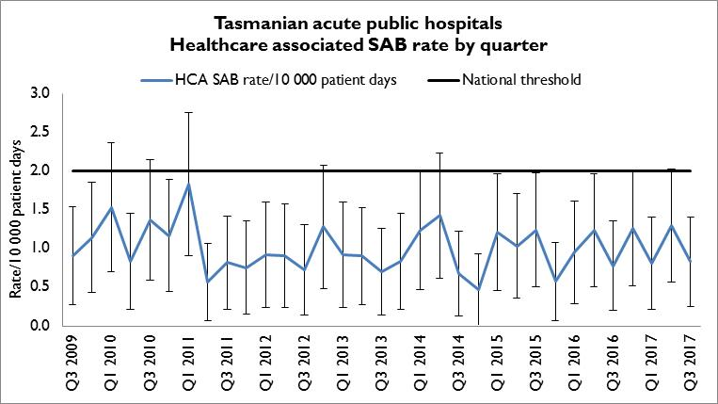
The rate of HCA SAB for Q3 2017 was 0.8 per 10 000 patient days (95% CI 0.3 – 1.4) which met the National Healthcare Agreement target of no more than two HCA SAB per10 000 patient days.

Hospital rates
Figure 2 Healthcare associated Staphylococcus aureus bacteraemia – rate by quarter
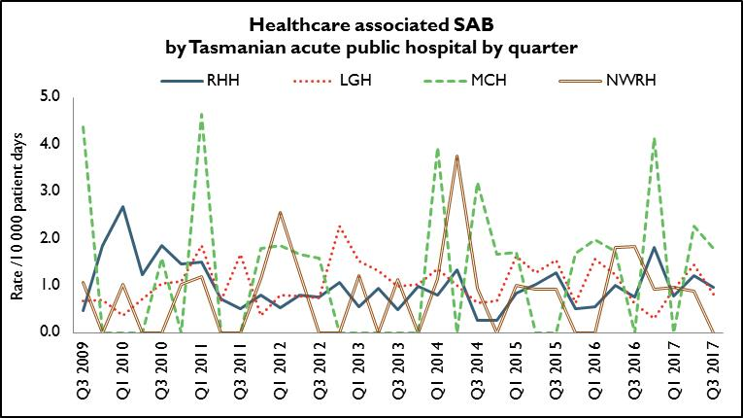
In Q3 2017, the rate of HCA SAB for all public hospitals met the National Healthcare Agreement target of no more than two HCA SAB per10 000 patient days.

Clostridium difficile infection
Clostridium difficile infection (CDI) is a bowel infection caused by the bacterium Clostridium difficile and is a common cause of healthcare associated diarrhoea. CDI causes significant patient morbidity and mortality and can result in increased hospital stays and costs. Factors that may contribute to higher CDI rates include the overuse of antibiotics, ineffective infection control processes and suboptimal environmental cleanliness.
Surveillance of CDI in Tasmania uses the ACSQHC’s national surveillance definitions. There is no National benchmark for CDI.
Hospital identified CDI are CDI infections identified in a hospital irrespective of attribution of infection.
Healthcare associated – healthcare facility onset (HCA-HCF) CDI are a sub-group of hospital identified cases. This category only includes infections that occurred 48 hours or more after a patient was admitted to hospital. The HCA – HCF rate excludes people who present to hospital with symptoms of CDI and/or develop symptoms within two days of admission.

Tasmanian rates
Figure 3 Acute public hospital identified CDI and HCA-HCF CDI – rates by quarter
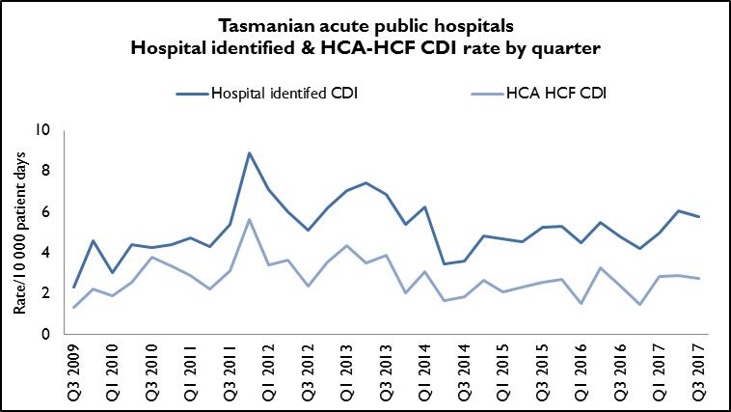
The rate of hospital identified CDI for Q3 2017 was 5.8 per 10 000 patient days (95%
CI 4.2 – 7.3) and the rate of HCA-HCF over the same period was 2.8 per10 000 patient days (95% CI 1.7 – 3.9).
The number of both hospital identified (n=52) and HCA-HCF (n=25) is the same as in the previous quarter, Q2 2017.
Hospital rates – by quarter
Figure 4 and Figure 5 presents the individual acute public hospital rates of hospital identified CDI and healthcare associated – healthcare facility onset (HCA-HCF) CDI by quarter.
Figure 4 Hospital identified CDI by quarter
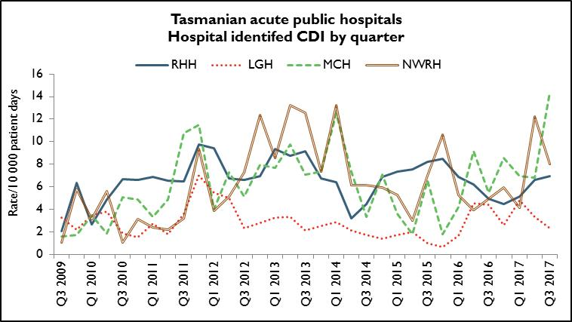
Figure 5 HCA-HCF CDI by quarter
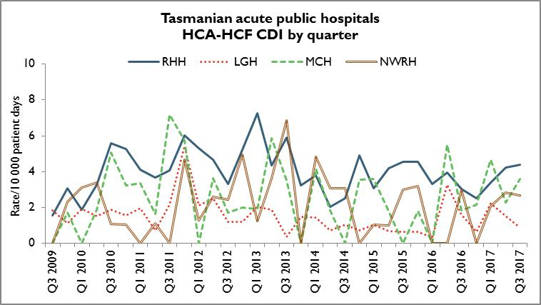

The rate of HCA-HCF CDI has remained relatively stable over the last two quarters in all four hospitals.

Vancomycin resistant enterococci
Enterococci are bacteria normally present in the human gastrointestinal and female genital tract and can cause infections of the urinary tract, bloodstream and wounds.
Enterococci that have acquired resistance to the antibiotic vancomycin are called vancomycin-resistant enterococci or VRE. VRE infections can be more difficult to treat then those caused by vancomycin sensitive enterococci.
Factors that can contribute to the transmission of VRE in hospitals are inadequate infection control practices, overuse of antibiotics and suboptimal environmental cleanliness.
Identification of VRE is notifiable in Tasmania pursuant to the Public Health Act 1997.
Figure 6 presents all patients with a first VRE isolate identified within Tasmania by quarter. These numbers include all new patients identified within Tasmania from public and private hospitals, rural hospitals, GP clinics and long term and residential care facilities. A person’s first VRE isolate is classified according to whether it represents colonisation or infection.

Figure 6 First VRE isolates – classification by quarter
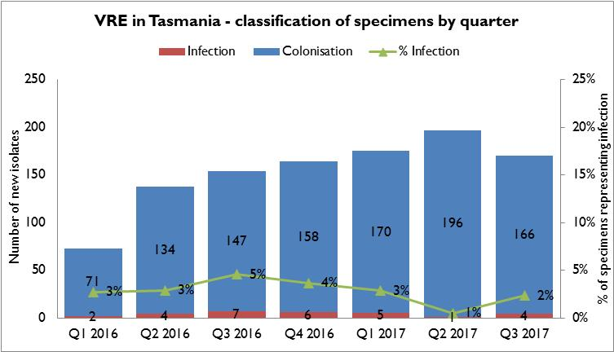
The number of people newly identified with VRE within hospitals does not necessarily reflect that VRE was acquired at that hospital. The numbers of VRE isolates identified can be affected by the amount of screening undertaken by hospitals.
Hospitals that have an intensive screening program are likely to identify more VRE. There has been a decrease in identification of VRE in Q3 2017 which is the first time in the past two years that it has decreased over the previous quarter.
Most isolates over that time have been, and continue to be, colonisations.
The proportion of isolates that represent infections has remained stable over the last seven quarters with infections representing around three per cent of total isolates.
Figure 7 First VRE isolates - genotype by quarter
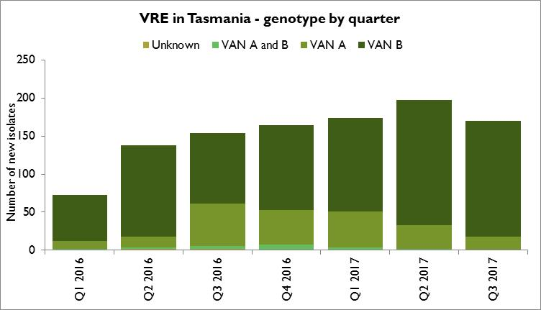
The majority of VRE within Tasmania remains vanB E. faecium. The number and proportion of isolates with the vanA genotype have continued to decrease over the past two quarters.
Molecular typing continues to be undertaken to gain a better understanding of VRE epidemiology within Tasmanian public hospitals.

Carbapenemase-producing Enterobacteriaceae
Carbapenem resistance in Enterobacteriaceae is an emerging clinical and public health problem that threatens the effectiveness of the last currently available antibiotic group – carbapenems – that are highly active against multi-drug resistant Gram negative organisms.
The epidemiology of Carbapenemase-producing Enterobacteriaceae (CPE) varies between countries and it is evident that without active surveillance and subsequent stringent infection control measures these organisms may rapidly become endemic.
In areas where few CPE cases have occurred, it is recommended that health departments take an aggressive approach to contain CPE.
With current low prevalence rates, surveillance through mandatory laboratory notification creates an opportunity for proactive measures to prevent, detect and contain CPE within Tasmania.
Identification of CPE was made notifiable in Tasmania pursuant to the Public Health Act 1997 in 2016.
There were no cases of CPE identified in Tasmania in Q3 2017.

Hand Hygiene
The National Hand Hygiene Initiative was introduced in Tasmania in 2009 to increase healthcare workers hand hygiene compliance and monitor its effectiveness by measuring reductions in HCA SAB.
Hand hygiene compliance is monitored by direct observation of healthcare workers performing hand hygiene at the appropriate times. Hand Hygiene Australia (HHA) requires hand hygiene compliance data to be submitted three times per year.
In 2017 the Australian Health Ministers Advisory Council (AHMAC) endorsed increasing the national compliance benchmark from ≥75 per cent to ≥80 per cent for total moments, individual moments and each healthcare worker group.

Tasmanian rates
Figure 8 Hand hygiene compliance in Tasmanian public hospitals
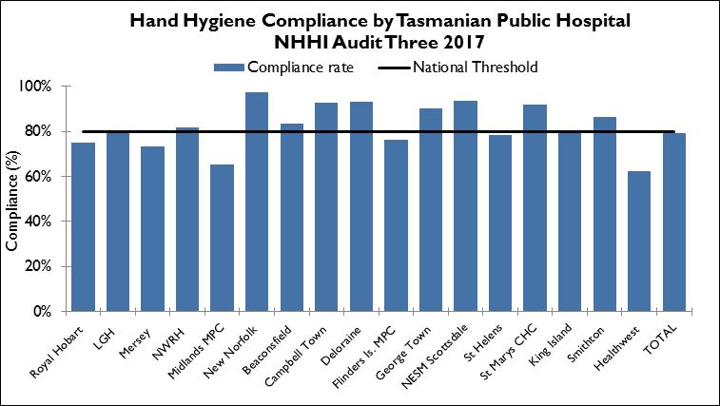
Audit period 3 is from 1 July 2017 to 31 October 2017. For this period the overall Tasmanian public hospital compliance rate was 79 per cent which was below the national threshold of 80 per cent.
The 2016-2017 Service Level Agreement between the Minister for Health and the Tasmanian Health Service (THS) states the hand hygiene compliance Key Performance Indicator (KPI) target as ≥ 80 per cent from 1 January 2017.
The consolidated compliance rate in Audit Period 3 2017 is the lowest since Audit Period 3 2015.
There are differences in the number of hand hygiene moments observed in the acute hospitals versus the rural hospitals and these numbers are presented in Table 13 in Appendix 2.

Figure 9 Hand hygiene compliance by moment
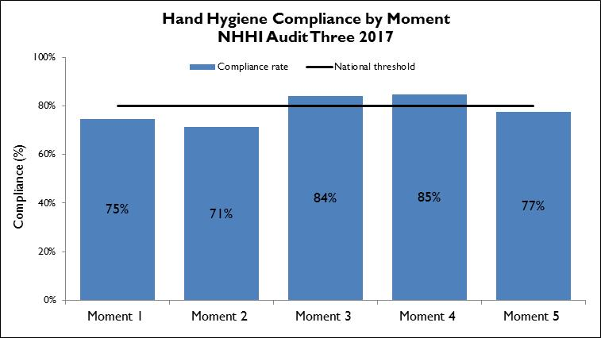
Hand hygiene compliance before touching a patient (Moment 1), undertaking a procedure (Moment 2) and after touching patient surroundings (Moment 5) are lower than the target of 80 per cent and lower than those reported after undertaking a procedure (Moment 3) or after touching a patient (Moment 4).
Moment 1 and Moment 2 are key opportunities for hand hygiene that may have a direct effect on the risk of transmission of pathogens within the healthcare setting.
Moment 2, particularly relates to compliance with appropriate aseptic technique and procedural activity.
These findings – less complience with Moments 1 and 2 than for Moments 3 and 4 – are consistent with the national data and work continues within Tasmania to increase the compliance in these moments.

Figure 10 Hand hygiene compliance by healthcare worker
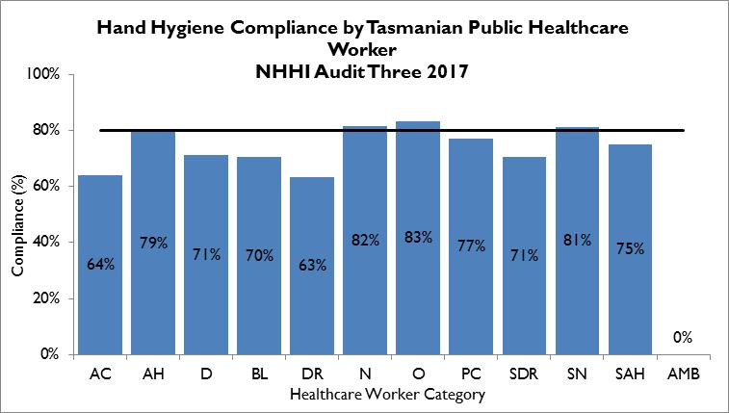
Table 1 Healthcare worker categories
Code | Healthcare worker | Code | Healthcare worker | Code | Healthcare worker
AC | Clerical | DR | Doctor | SDR | Student Doctor
AH | Allied Health | N | Nurse/Midwife | SN | Student Nurse/Midwife
D | Domestic | O | Other | SAH | Student Allied Health
BL | Invasive Technician | PC | Personal Care Staff | AMB | Ambulance worker

This year HHA introduced a new healthcare worker category – Ambulance Worker. Limited moments have been collected for this healthcare worker group to date.
The number of hand hygiene moments observed between the different healthcare worker groups varies. Most (72 per cent in audit period 3, 2017) were collected from nurse-patient interactions with the next highest being doctor-patient interactions (10 per cent).
There are a number of healthcare worker groups – clerical, invasive technician, student doctor, student allied healthcare worker, ambulance worker and other – that contribute less than one per cent of the total hand hygiene moments thus their results should be interpreted with caution.
Of the healthcare worker groups that contribute more than one per cent of the total moments, allied health staff, personal care staff, doctors and domestic staff are not meeting the compliance target of 80 per cent. Doctor compliance at 63 per cent, is well below the benchmark and has dropped over each of the last three audit periods.
TIPCU is working with HHA and the hospitals to address this concern.

Acknowledgements
The production of this report is the culmination of data collection, analysis and input from several different organisations. In particular, we would like to acknowledge:
- Executive Director of Nursing THS North
- Executive Director of Nursing THS North West
- Executive Director of Nursing THS South
- Launceston General Hospital Infection Prevention and Control Unit
- North West Regional Hospital Infection Control Team
- Mersey Community Hospital Infection Control Team
- Royal Hobart Hospital Infection Prevention and Control Unit
- Microbiology Departments at the Royal Hobart Hospital, Launceston General Hospital and DSPL
- Hand Hygiene Australia
- Communicable Diseases Prevention Unit, Public Health Services
- Contributing Primary Health Sites

Appendix 1

Explanatory notes

What types of healthcare surveillance are done in Tasmania?
TIPCU undertakes surveillance of the following:
- Staphylococcus aureus bacteraemia (bloodstream infection).
- Clostridium difficile infection (CDI).
- Vancomycin resistant enterococci (VRE).
- Carbapenemsae
- Hand hygiene compliance rates.
- Antibiotic utilisation – reported annually.

What do the rates mean?
The healthcare surveillance data are expressed as a rate or a raw number. SAB and CDI are expressed as a rate per 10 000 patient days, VRE is expressed as a raw number, hand hygiene compliance is expressed as a percentage and antibiotic utilisation is expressed as hospital use measured by defined daily doses, per 1 000 occupied bed days.

What are the definitions for Clostridium difficile infection (CDI)?
TIPCU use the national surveillance definitions published by the Australian Commission on Safety and Quality in Health Care (ACSQHC) to classify CDI. TIPCU reports on:
- Hospital identified CDI is defined as a case diagnosed in a patient attending an acute care facility. This includes positive specimens obtained from admitted patients and those attending the emergency department and outpatient departments. This definition excludes patients less than two years old and cases with a positive test within the previous eight weeks.
- Healthcare associated – healthcare facility onset CDI (HCA-HCF CDI) is defined as a patient with CDI symptom onset (or date and time of stool specimen collection if a laboratory system is used) more than 48 hours after admission to a healthcare facility. This definition excludes patients less than two years old and cases with a positive test within the previous eight weeks.

What are the definitions for healthcare associated Staphylococcus aureus bacteraemia (SAB)?
Criterion A the patient’s first SAB blood culture was collected more than 48 hours after hospital admission or less than 48 hours after discharge.
OR
Criterion B the patient’s first positive SAB blood culture was collected less than or equal to 48 hours after hospital admission and one or more of the following key clinical criteria was met for the patient-episode of SAB.
Key clinical criteria:
- SAB is a complication of the presence of an indwelling medical device (eg intravascular line, haemodialysis vascular access, CSF shunt, urinary catheter).
- SAB occurs within 30 days of a surgical procedure or 365 days for surgically implanted devices, where the SAB is related to the surgical site.
- SAB was diagnosed within 48 hours of a related invasive instrumentation or incision.
- SAB is associated with neutropenia (less 1 x 10⁹/L) contributed to by cytotoxic therapy.
What is the definition for vancomycin resistant enterococci (VRE)?
The definition for VRE is an isolate identified as VRE by an accredited laboratory.
TIPCU reports on the total number of people with new isolates of VRE identified in Tasmania per quarter and this number includes all people with new VRE isolates from public and private hospitals, rural hospitals, GP clinics and long term and residential care facilities.
What is the definition for Carbapenemase producing Enterobacteriaceae (CPE)?
The definition for CPE is an Enterobacteriaceae isolate with a carbapenemase gene detected
identified by an accredited laboratory.
TIPCU reports on the total number of people with new isolates of CPE identified in Tasmania per annum and this number includes all people with new CPE isolates from public and private hospitals, rural hospitals, GP clinics and long term and residential care facilities.

Confidence intervals
Confidence intervals are used to calculate the range in which the true rate probably lies.
As an example, when looking at the hand hygiene compliance (HHC) data confidence intervals calculate the range in which the true compliance result lies, based on the data collected and the compliance measured, thus providing an indication of the reliability of the reported HHC level.
When only a small number of moments are collected, the confidence interval will be larger, as it is more difficult to establish the true compliance level from a small sample of moments.
If a large number of moments are collected the confidence interval will be smaller, meaning the reliability of the result is higher.
Hand Hygiene Australia (HHA) calculates 95 per cent confidence intervals, indicating the intervals in which 95 per cent of the time the true compliance level lies. (HHA 2011).
Patient care days
Patient days is the term to explain the total days patients are in hospital. In each of Tasmania’s four larger acute public hospitals there are around 330 000 patient care days a year.
When a rate is presented as a number per 10 000 patient days this presents the number of infections that occur for every 10 000 patient care days.

Can I compare Tasmanian hospital infection rates?
Each Tasmanian hospital provides different services and has patients with different levels of illness. This affects infection rates.
For example, very sick immuno-compromised patients may be more likely to get infections.
It is difficult to remove all of the factors outside the control of a hospital that can cause its infection rate to differ from other hospitals.
Other reasons for caution when comparing hospitals include:
- some hospitals may screen patients more than others. This can affect data for CDI and VRE in particular
- hospital laboratories may use different ways of identifying organisms. A laboratory that has a more sensitive way of looking for organisms may find more
- for hand hygiene, rural hospitals are not required to collect as many moments as the four acute public hospitals, which limits the comparability of data for rural and acute hospitals.

Appendix 2

Healthcare associated Staphylococcus aureus bacteraemia (SAB)
Table 2 Tasmanian numbers and rate per 10 000 patient days of HCA-SAB.
Quarter | Total HCA-SAB | Number MSSA | Number MRSA | HCA SAB Rate
Q1 2012 | 7 | 6 | 1 | 0.9
Q2 2012 | 7 | 6 | 1 | 0.9
Q3 2012 | 6 | 6 | 0 | 0.7
Q4 2012 | 10 | 9 | 1 | 1.3
Q1 2013 | 7 | 7 | 0 | 0.9
Q2 2013 | 8 | 7 | 1 | 0.9
Q3 2013 | 6 | 6 | 0 | 0.7
Q4 2013 | 7 | 7 | 0 | 0.8
Q1 2014 | 10 | 9 | 1 | 1.2
Q2 2014 | 12 | 10 | 2 | 1.4
Q3 2014 | 6 | 6 | 0 | 0.7
Q4 2014 | 4 | 4 | 0 | 0.5
Q1 2015 | 10 | 9 | 1 | 1.2
Q2 2015 | 9 | 7 | 2 | 1.0
Q3 2015 | 12 | 10 | 2 | 1.4
Q4 2015 | 5 | 4 | 1 | 0.6
Q1 2016 | 8 | 6 | 2 | 1.0
Q2 2016 | 11 | 10 | 1 | 1.2
Q3 2016 | 7 | 7 | 0 | 0.8
Q4 2016 | 11 | 10 | 1 | 1.3
Q1 2017 | 7 | 6 | 1 | 0.8
Q2 2017 | 12 | 10 | 2 | 1.3
Q3 2017 | 8 | 8 | 0 | 0.8

Table 3 Royal Hobart Hospital numbers and rates per10 000 patient days of HCA-SAB
Quarter | Total HCA-SAB | Number MSSA | Number MRSA | HCA SAB Rate
Q3 2012 | 3 | 3 | 0 | 0.8
Q4 2012 | 4 | 4 | 0 | 1.1
Q1 2013 | 2 | 2 | 0 | 0.6
Q2 2013 | 4 | 4 | 0 | 0.9
Q3 2013 | 2 | 2 | 0 | 0.5
Q4 2013 | 4 | 4 | 0 | 1.0
Q1 2014 | 3 | 3 | 0 | 0.8
Q2 2014 | 5 | 4 | 1 | 1.3
Q3 2014 | 1 | 1 | 0 | 0.3
Q4 2014 | 1 | 0 | 0 | 0.3
Q1 2015 | 3 | 2 | 1 | 0.8
Q2 2015 | 4 | 4 | 0 | 1.0
Q3 2015 | 5 | 5 | 0 | 1.3
Q4 2015 | 2 | 2 | 0 | 0.5
Q1 2016 | 2 | 2 | 0 | 0.5
Q2 2016 | 4 | 4 | 0 | 1.0
Q3 2016 | 3 | 3 | 0 | 0.8
Q4 2016 | 7 | 7 | 0 | 1.8
Q1 2017 | 3 | 2 | 1 | 0.8
Q2 2017 | 5 | 5 | 0 | 1.2
Q3 2017 | 4 | 4 | 0 | 1.0

Table 4 Launceston General Hospital numbers and rates per10 000 patient days of HCA-SAB
Quarter | Total HCA-SAB | Number MSSA | Number MRSA | HCA SAB Rate
Q3 2012 | 2 | 2 | 0 | 0.7
Q4 2012 | 6 | 5 | 1 | 2.3
Q1 2013 | 4 | 4 | 0 | 1.5
Q2 2013 | 4 | 3 | 1 | 1.3
Q3 2013 | 3 | 3 | 0 | 1.0
Q4 2013 | 3 | 3 | 0 | 1.0
Q1 2014 | 4 | 4 | 0 | 1.4
Q2 2014 | 3 | 2 | 1 | 1.0
Q3 2014 | 2 | 2 | 0 | 0.6
Q4 2014 | 2 | 2 | 0 | 0.7
Q1 2015 | 5 | 5 | 0 | 1.6
Q2 2015 | 4 | 2 | 2 | 1.3
Q3 2015 | 5 | 3 | 2 | 1.5
Q4 2015 | 2 | 1 | 1 | 0.6
Q1 2016 | 5 | 3 | 2 | 1.6
Q2 2016 | 4 | 4 | 0 | 1.2
Q3 2016 | 2 | 2 | 0 | 0.6
Q4 2016 | 1 | 0 | 1 | 0.3
Q1 2017 | 3 | 3 | 0 | 0.9
Q2 2017 | 5 | 3 | 2 | 1.4
Q3 2017 | 3 | 3 | 0 | 0.8

Table 5 Mersey Community Hospital numbers and rates per10 000 patient days of HCA-SAB
Quarter | Total HCA-SAB | Number MSSA | Number MRSA | HCA SAB Rate
Q3 2012 | 1 | 1 | 0 | 1.6
Q4 2012 | 0 | 0 | 0 | 0.0
Q1 2013 | 0 | 0 | 0 | 0.0
Q2 2013 | 0 | 0 | 0 | 0.0
Q3 2013 | 0 | 0 | 0 | 0.0
Q4 2013 | 0 | 0 | 0 | 0.0
Q1 2014 | 2 | 2 | 0 | 3.9
Q2 2014 | 0 | 0 | 0 | 0.0
Q3 2014 | 2 | 2 | 0 | 3.2
Q4 2014 | 1 | 1 | 0 | 1.7
Q1 2015 | 1 | 1 | 0 | 1.7
Q2 2015 | 0 | 0 | 0 | 0.0
Q3 2015 | 1 | 1 | 0 | 1.5
Q4 2015 | 1 | 1 | 0 | 1.7
Q1 2016 | 1 | 1 | 0 | 2.0
Q2 2016 | 1 | 1 | 0 | 1.7
Q3 2016 | 0 | 0 | 0 | 0.0
Q4 2016 | 2 | 2 | 0 | 4.2
Q1 2017 | 0 | 0 | 0 | 0.0
Q2 2017 | 1 | 1 | 0 | 2.3
Q3 2017 | 1 | 1 | 0 | 1.8

Table 6 North West Regional Hospital numbers and rates per10 000 patient days of HCA-SAB.
Quarter | Total HCA-SAB | Number MSSA | Number MRSA | HCA SAB Rate
Q3 2012 | 0 | 0 | 0 | 0.0
Q4 2012 | 0 | 0 | 0 | 0.0
Q1 2013 | 1 | 1 | 0 | 1.2
Q2 2013 | 0 | 0 | 0 | 0.0
Q3 2013 | 1 | 1 | 0 | 1.1
Q4 2013 | 0 | 0 | 0 | 0.0
Q1 2014 | 1 | 0 | 1 | 1.2
Q2 2014 | 4 | 4 | 0 | 3.7
Q3 2014 | 1 | 1 | 0 | 1.0
Q4 2014 | 0 | 0 | 0 | 0.0
Q1 2015 | 1 | 1 | 0 | 1.0
Q2 2015 | 1 | 1 | 0 | 0.9
Q3 2015 | 1 | 1 | 0 | 0.9
Q4 2015 | 0 | 0 | 0 | 0.0
Q1 2016 | 0 | 0 | 0 | 0.0
Q2 2016 | 2 | 1 | 1 | 1.8
Q3 2016 | 2 | 2 | 0 | 1.8
Q4 2016 | 1 | 1 | 0 | 0.9
Q1 2017 | 1 | 1 | 0 | 1.0
Q2 2017 | 1 | 1 | 0 | 0.9
Q3 2017 | 0 | 0 | 0 | 0.0

Clostridium difficile infection (CDI)
Table 7 Tasmanian numbers and rates per10 000 patient days of CDI
Quarter | Total hospital identified CDI | Hospital identified Rate | Total HCA HCF | HCA HCF Rate
Q1 2012 | 50 | 7.1 | 24 | 3.4
Q2 2012 | 43 | 6.0 | 26 | 3.6
Q3 2012 | 39 | 5.1 | 18 | 2.4
Q4 2012 | 45 | 6.2 | 26 | 3.6
Q1 2013 | 50 | 7.1 | 31 | 4.4
Q2 2013 | 57 | 7.5 | 27 | 3.6
Q3 2013 | 55 | 6.9 | 31 | 3.9
Q4 2013 | 42 | 5.4 | 16 | 2.1
Q1 2014 | 47 | 6.3 | 23 | 3.1
Q2 2014 | 27 | 3.5 | 13 | 1.7
Q3 2014 | 27 | 3.4 | 15 | 1.9
Q4 2014 | 38 | 4.8 | 21 | 2.7
Q1 2015 | 36 | 4.7 | 16 | 2.1
Q2 2015 | 37 | 4.6 | 19 | 2.3
Q3 2015 | 43 | 5.2 | 21 | 2.6
Q4 2015 | 43 | 5.3 | 22 | 2.7
Q1 2016 | 35 | 4.5 | 12 | 1.5
Q2 2016 | 45 | 5.5 | 17 | 2.1
Q3 2016 | 40 | 4.8 | 20 | 2.4
Q4 2016 | 34 | 4.2 | 12 | 1.5
Q1 2017 | 40 | 5.0 | 23 | 2.9
Q2 2017 | 52 | 6.1 | 25 | 2.9
Q3 2017 | 52 | 5.8 | 25 | 2.8

Table 8 Hospital numbers and rates per10 000 patient days of hospital identified CDI
Quarter | RHH Total | RHH Rate | LGH Total | LGH Rate | MCH Total | MCH Rate | NWRH Total | NWRH Rate
Q1 2012 | 32 | 9.4 | 13 | 5.5 | 2 | 4.0 | 3 | 3.9
Q2 2012 | 23 | 6.7 | 12 | 5.0 | 4 | 7.3 | 4 | 5.2
Q3 2012 | 24 | 6.6 | 6 | 2.4 | 3 | 5.1 | 6 | 7.3
Q4 2012 | 24 | 6.9 | 7 | 2.8 | 4 | 7.9 | 10 | 12.3
Q1 2013 | 31 | 9.4 | 8 | 3.3 | 4 | 7.7 | 7 | 8.6
Q2 2013 | 32 | 8.7 | 9 | 3.4 | 5 | 9.8 | 11 | 13.2
Q3 2013 | 34 | 9.1 | 6 | 2.1 | 4 | 7.0 | 11 | 12.5
Q4 2013 | 25 | 6.8 | 7 | 2.6 | 4 | 7.3 | 6 | 7.3
Q1 2014 | 22 | 6.4 | 8 | 2.9 | 6 | 12.5 | 11 | 13.2
Q2 2014 | 11 | 3.2 | 6 | 2.1 | 4 | 7.3 | 6 | 6.1
Q3 2014 | 16 | 4.5 | 5 | 1.7 | 2 | 3.4 | 6 | 6.2
Q4 2014 | 24 | 6.9 | 4 | 1.4 | 4 | 7.1 | 6 | 5.9
Q1 2015 | 24 | 7.4 | 5 | 1.7 | 2 | 3.6 | 5 | 5.3
Q2 2015 | 27 | 7.5 | 6 | 2.0 | 1 | 1.8 | 3 | 3.0
Q3 2015 | 29 | 8.2 | 3 | 1.0 | 4 | 6.5 | 7 | 7.0
Q4 2015 | 30 | 8.5 | 2 | 0.7 | 1 | 1.8 | 10 | 10.6
Q1 2016 | 23 | 6.9 | 5 | 1.6 | 2 | 4.2 | 5 | 5.3
Q2 2016 | 22 | 6.2 | 14 | 4.6 | 5 | 9.2 | 4 | 3.9
Q3 2016 | 18 | 5.0 | 14 | 4.4 | 3 | 5.5 | 5 | 4.9
Q4 2016 | 16 | 4.5 | 8 | 2.6 | 4 | 8.6 | 6 | 5.9
Q1 2017 | 18 | 5.1 | 15 | 4.8 | 3 | 7.0 | 4 | 4.2
Q2 2017 | 25 | 6.6 | 11 | 3.3 | 3 | 6.8 | 13 | 12.3
Q3 2017 | 27 | 6.9 | 8 | 2.3 | 8 | 14.4 | 9 | 8.0

Table 9 Hospital numbers and rates per10 000 patient days of HCA-HCF CDI
Quarter | RHH Total | RHH Rate | LGH Total | LGH Rate | MCH Total | MCH Rate | NWRH Total | NWRH Rate
Q1 2012 | 18 | 5.3 | 5 | 2.1 | 0 | 0.0 | 1 | 1.3
Q2 2012 | 16 | 4.7 | 6 | 2.5 | 2 | 3.6 | 2 | 2.6
Q3 2012 | 12 | 3.3 | 3 | 1.2 | 1 | 1.7 | 2 | 2.4
Q4 2012 | 18 | 5.2 | 3 | 1.2 | 1 | 2.0 | 4 | 4.9
Q1 2013 | 24 | 7.2 | 5 | 2.1 | 1 | 1.9 | 1 | 1.2
Q2 2013 | 16 | 4.4 | 5 | 1.9 | 3 | 5.9 | 3 | 3.6
Q3 2013 | 22 | 5.9 | 1 | 0.4 | 2 | 3.5 | 6 | 6.8
Q4 2013 | 12 | 3.2 | 4 | 1.5 | 0 | 0.0 | 0 | 0.0
Q1 2014 | 13 | 3.8 | 4 | 1.4 | 2 | 4.2 | 4 | 4.8
Q2 2014 | 7 | 2.0 | 2 | 0.7 | 1 | 1.8 | 3 | 3.1
Q3 2014 | 9 | 2.5 | 3 | 1.0 | 0 | 0.0 | 3 | 3.1
Q4 2014 | 17 | 4.9 | 2 | 0.7 | 2 | 3.5 | 0 | 0.0
Q1 2015 | 10 | 3.1 | 3 | 1.0 | 2 | 3.6 | 1 | 1.1
Q2 2015 | 15 | 4.2 | 2 | 0.7 | 1 | 1.8 | 1 | 1.0
Q3 2015 | 16 | 4.5 | 2 | 0.7 | 0 | 0.0 | 3 | 3.0
Q4 2015 | 16 | 4.5 | 2 | 0.7 | 1 | 1.8 | 3 | 3.2
Q1 2016 | 11 | 3.3 | 1 | 0.3 | 0 | 0.0 | 0 | 0.0
Q2 2016 | 14 | 3.9 | 10 | 3.3 | 3 | 5.5 | 0 | 0.0
Q3 2016 | 11 | 3.0 | 5 | 1.6 | 1 | 1.8 | 3 | 3.0
Q4 2016 | 9 | 2.5 | 2 | 0.7 | 1 | 2.1 | 0 | 0.0
Q1 2017 | 12 | 3.4 | 7 | 2.2 | 2 | 4.7 | 2 | 2.1
Q2 2017 | 16 | 4.2 | 5 | 1.5 | 1 | 2.3 | 3 | 2.8
Q3 2017 | 17 | 4.4 | 3 | 0.9 | 2 | 3.6 | 3 | 2.7

Vancomycin resistant enterococci (VRE)
Table 10 First VRE isolates identified per quarter within a) acute public hospitals, b) other healthcare settings (private hospitals, rural hospitals, GP clinics and long term and residential care facilities) and c) total Tasmanian isolates.
Quarter | RHH | LGH | MCH | NWRH | Other healthcare settings | TOTAL
Q1 2012 | 3 | 2 | 2 | 2 | 1 | 10
Q2 2012 | 4 | 2 | 0 | 1 | 0 | 7
Q3 2012 | 3 | 2 | 2 | 0 | 1 | 8
Q4 2012 | 1 | 7 | 1 | 1 | 2 | 12
Q1 2013 | 13 | 0 | 3 | 0 | 2 | 18
Q2 2013 | 8 | 3 | 0 | 1 | 3 | 15
Q3 2013 | 8 | 1 | 0 | 2 | 1 | 12
Q4 2013 | 5 | 3 | 0 | 3 | 5 | 6
Q1 2014 | 5 | 0 | 1 | 13 | 1 | 8
Q2 2014 | 3 | 6 | 1 | 1 | 2 | 13
Q3 2014 | 1 | 2 | 3 | 2 | 0 | 8
Q4 2014 | 1 | 5 | 1 | 5 | 7 | 19
Q1 2015 | 10 | 12 | 2 | 5 | 7 | 36
Q2 2015 | 5 | 13 | 2 | 1 | 8 | 29
Q3 2015 | 33 | 17 | 9 | 5 | 19 | 83
Q4 2015 | 36 | 22 | 0 | 11 | 13 | 82
Q1 2016 | 28 | 26 | 7 | 4 | 8 | 73
Q2 2016 | 51 | 48 | 12 | 14 | 12 | 138
Q3 2016 | 30 | 65 | 8 | 23 | 28 | 154
Q4 2016 | 51 | 67 | 5 | 15 | 26 | 164
Q1 2017 | 41 | 82 | 13 | 13 | 26 | 175
Q2 2017 | 70 | 78 | 9 | 12 | 28 | 197
Q3 2017 | 28 | 89 | 10 | 11 | 32 | 170

Table 11 Classification of first VRE isolates – colonisation and infection
Quarter | Total VRE | Colonisation | Infection | % infection
Q1 2012 | 10 | 8 | 2 | 20%
Q2 2012 | 7 | 7 | 0 | 0%
Q3 2012 | 8 | 8 | 0 | 0%
Q4 2012 | 12 | 9 | 3 | 25%
Q1 2013 | 18 | 18 | 0 | 0%
Q2 2013 | 15 | 13 | 2 | 13%
Q3 2013 | 12 | 11 | 1 | 8%
Q4 2013 | 16 | 16 | 0 | 0%
Q1 2014 | 8 | 7 | 1 | 13%
Q2 2014 | 13 | 13 | 0 | 0%
Q3 2014 | 8 | 8 | 0 | 0%
Q4 2014 | 19 | 19 | 0 | 0%
Q1 2015 | 36 | 29 | 7 | 19%
Q2 2015 | 29 | 18 | 11 | 38%
Q3 2015 | 83 | 77 | 6 | 7%
Q4 2015* | 82 | 76 | 3 | 4%
Q1 2016 | 73 | 71 | 2 | 3%
Q2 2016 | 138 | 134 | 4 | 3%
Q3 2016 | 154 | 147 | 17 | 5%
Q4 2016 | 164 | 158 | 6 | 4%
Q1 2017 | 175 | 170 | 5 | 3%
Q2 2017 | 197 | 196 | 1 | 1%
Q3 2017 | 170 | 166 | 4 | 2%
* 3 specimens unknown if represented colonisation or infection.

Table 12 First VRE isolates by genotype by quarter
Quarter | VAN A | VAN B | VAN A and B | Unknown
Q1 2012 | 2 | 7 | 1 | 0
Q2 2012 | 2 | 5 | 0 | 0
Q3 2012 | 1 | 7 | 0 | 0
Q4 2012 | 1 | 10 | 0 | 1
Q1 2013 | 0 | 18 | 0 | 0
Q2 2013 | 1 | 14 | 0 | 0
Q3 2013 | 0 | 12 | 0 | 0
Q4 2013 | 0 | 16 | 0 | 0
Q1 2014 | 1 | 7 | 0 | 0
Q2 2014 | 1 | 11 | 0 | 1
Q3 2014 | 0 | 8 | 0 | 0
Q4 2014 | 2 | 17 | 0 | 0
Q1 2015 | 3 | 33 | 0 | 0
Q2 2015 | 2 | 27 | 0 | 0
Q3 2015 | 3 | 78 | 0 | 2
Q4 2015* | 2 | 80 | 0 | 0
Q1 2016 | 10 | 61 | 1 | 1
Q2 2016 | 14 | 120 | 2 | 2
Q3 2016 | 55 | 93 | 4 | 2
Q4 2016 | 46 | 111 | 7 | 0
Q1 2017 | 47 | 119 | 4 | 1
Q2 2017 | 31 | 164 | 1 | 1
Q3 2017 | 18 | 152 | 0 | 0

Hand hygiene compliance data October 2017
Table 13 Hand hygiene compliance rates by Tasmanian hospital and state level
Hospital Name | HH Correctly Performed | HH Moments | Compliance | Lower 95% confidence interval | Upper 95% confidence interval
Royal Hobart | 2015 | 2683 | 75% | 73% | 77%
LGH | 4670 | 5823 | 80% | 79% | 81%
Mersey | 685 | 934 | 73% | 70% | 76%
NWRH | 836 | 11022 | 82% | 79% | 84%
Midlands MPC | 34 | 52 | 65% | 52% | 77%
New Norfolk | 71 | 73 | 97% | 91% | 99%
Beaconsfield | 50 | 60 | 83% | 72% | 91%
Campbell Town | 89 | 96 | 93% | 86% | 96%
Deloraine | 124 | 133 | 93% | 88% | 96%
Flinders Is. MPC | 71 | 93 | 76% | 67% | 84%
George Town | 75 | 83 | 90% | 82% | 95%
NESM Scottsdale | 74 | 79 | 94% | 86% | 97%
St Helens | 29 | 37 | 78% | 63% | 89%
St Marys CHC | 80 | 87 | 92% | 84% | 96%
King Island | 62 | 78 | 79% | 69% | 87%
Smithton | 63 | 73 | 86% | 77% | 92%
Healthwest | 43 | 69 | 62% | 51% | 73%
TOTAL | 9071 | 11475 | 79% | 78% | 80%

Table 14 Tasmanian hand hygiene compliance rates by moment
Moments | HH Correctly Performed | Total HH Moments | Compliance | Lower 95% confidence interval | Upper 95% confidence interval
Moment 1 | 2374 | 3182 | 75% | 73% | 76%
Moment 2 | 573 | 804 | 71% | 68% | 74%
Moment 3 | 988 | 1176 | 84% | 82% | 86%
Moment 4 | 2938 | 3472 | 85% | 83% | 86%
Moment 5 | 2198 | 2841 | 77% | 76% | 79%
TOTAL | 9071 | 11475 | 79% | 78% | 80%

Table 15 Tasmanian hand hygiene compliance rates by healthcare worker
Staff Type | HH Correctly Performed | HH Moments | Compliance | Lower 95% confidence interval | Upper 95% confidence interval
Clerical | 16 | 25 | 64% | 45% | 80%
Allied Health | 269 | 339 | 79% | 75% | 83%
Domestic | 147 | 206 | 71% | 65% | 77%
Invasive Technician | 62 | 88 | 70% | 60% | 79%
Doctor | 746 | 1177 | 63% | 61% | 66%
Nurse/Midwife | 6708 | 8224 | 82% | 81% | 82%
Other | 50 | 60 | 83% | 72% | 91%
Personal care staff | 460 | 596 | 77% | 74% | 80%
Student Doctor | 24 | 34 | 71% | 54% | 83%
Student Nurse/Midwife | 583 | 717 | 81% | 78% | 84%
Student Allied Health | 6 | 8 | 75% | 41% | 93%
Ambulance worker | 0 | 1 | 0% | 0% | 79%
TOTAL | 9071 | 11475 | 79% | 78% | 80%

