Contents
1 Abstract 3
2 Introduction 4
3 Principles and Strategic Priorities 5
3.1 Australian National Diabetes Strategy 2016-20 5
3.2 Diabetes Australia: Strategic Directions 6
4 Summary of Findings 7
4.1 Diabetes as a Chronic Condition 7
4.2 How common is diabetes? 7
4.3 Risk Factors 12
4.4 Prevention 14
4.5 Burden of the Disease 14
4.6 Co-morbidity 16
4.7 Hospitalisations 17
4.8 Mortality 21
4.9 Discussion 23
5 Diabetes – Future Purchasing Strategies 24
Works Cited 25

- Abstract
The objective of the State’s public sector health system is to deliver safe, high quality services to improve, promote, protect and maintain the health of Tasmanians. This objective supports the vision for Tasmania to have the healthiest population in Australia by 2025.
The Statement of Purchaser Intent (SoPI) acts as the bridge between the Strategic Priorities of the Health System and the transactional activity of purchasing. The strategic intent behind this is to create a common language between the Department of Health and Human Services (DHHS) as purchaser, the Government as funder, clinicians as service providers and the Tasmanian community as users.
The SoPI 2017-18 identifies Diabetes as a future priority to review and develop purchasing intentions and activity, and highlighting that further work needs to be undertaken to understand the coded data environment before purchasing actions related to Diabetes can be formulated.
The SoPI 2018/19 Supplementary Paper 1: Diabetes research and discussion paper is an opportunity to:
- consider current approaches to Diabetes services and care within Tasmania;
- consider the role of the DHHS and Tasmanian Health Service (THS), as well as other stakeholders;
- evaluate whether current service planning, delivery, and investments align with identified needs;
- maximise the efficient use of existing limited health care resources;
- articulate a vision for preventing, detecting and managing diabetes; and
- identify opportunities for diabetes research.
This paper identifies the available evidence base to be able to measure the prevalence level of Diabetes across Tasmania. This data will assist the identification of planned services that could be purchased in future SoPI cycles contributing to the prevention or easing of the significant burden of Diabetes in Tasmania’s population.
- Introduction
As part of the Strategic Purchasing Framework, a rolling 5 year Statement of Purchaser’s Intent (SoPI) is developed. Each year, the SoPI will widen the focus of purchasing intent from acute care to anticipatory and preventative care in the community and private sectors where the cost is less.
As part of this development, this paper summarises and references the available national and Tasmanian prevalence, incidence, and burden of disease data trends for diabetes, including the impact of co-morbidity, non-fatal/fatal burden, mortality and associated risk factors.
The use of information and data on the health impacts and distribution of different diseases, injuries and risk factors is crucial in providing an evidence base to inform health policy, program and service delivery. In turn, this helps to ensure health resources are directed towards services that are cost-effective, equitable and optimise the health of Tasmanians.
Continuity of care across the health system is important for patients, their families and carers, and health care providers. It is increasingly recognised that community engagement in health prevention can also be highly influential in improving the overall health of communities and, by extension, the individuals within those communities.
The Department of Health and Human Services (DHHS) has a responsibility to contribute to keeping Tasmanians healthy and out of hospital. In part, this is achieved through configuring the health system to provide better access to quality health care appropriate to individual needs, and fostering partnerships between the Tasmanian Health Service (THS) and service providers (Departmental, non-government and private sector). Partnering between General Practitioners (GPs) and other clinical providers is key to the sustainability and effective operation of both the primary and acute care sectors.
The activities that occur in the primary and community sectors impact upon the kinds and levels of demand experienced by the acute sector, and it is therefore important to understand and measure the needs of the community so that we can purchase the most appropriate services for the greatest positive effect.
- Principles and Strategic Priorities
The DHHS will work in accordance with the vision, principles and strategic priorities outlined in the ‘DHHS Corporate Plan 2016-18’ to keep Tasmanians safe, healthy and well.
The Tasmanian Health System Purchasing Framework figure below outlines the Purchaser Principles to support the DHHS to guide health service planning and delivery in Tasmania:
Figure 1: Tasmanian Health System Purchasing Framework
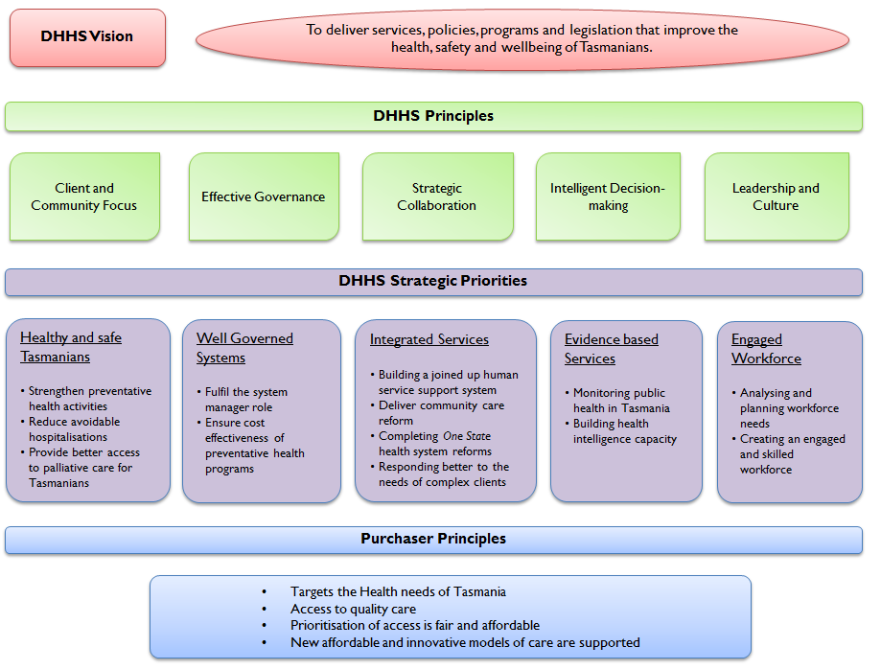
  - Australian National Diabetes Strategy 2016-20
The Australian National Diabetes Strategy 2016-20 aims to outline Australia’s national response to diabetes and inform how existing limited health care resources can be better coordinated and targeted across all levels of government. The Strategy identifies the most effective and appropriate interventions to reduce the impact of diabetes in the community and lead the way internationally in diabetes prevention, management and research.
The Australian National Diabetes Strategy outlines seven high-level goals with potential areas for action and measures of progress:
- Prevent people developing type 2 diabetes
- Promote awareness and earlier detection of type 1 and type 2 diabetes
- Reduce the occurrence of diabetes-related complications and improve quality of life among people with diabetes
- Reduce the impact of pre-existing and gestational diabetes in pregnancy
- Reduce the impact of diabetes among Aboriginal and Torres Strait Islander peoples
- Reduce the impact of diabetes among other priority groups
- Strengthen prevention and care through research, evidence and data
(Department of Health, Aust Govt, 2015, p. 7)
  - Diabetes Australia: Strategic Directions
Diabetes Australia is the national body for people affected by all types of diabetes and those at risk. Through leadership, prevention, management and research, Diabetes Australia is committed to reducing the impact of diabetes.
Diabetes Australia works to raise the awareness about the seriousness of diabetes, promoting prevention and early detection strategies and advocating for better standards of care. Diabetes Australia is also a significant financial contributor to research into better treatments for diabetes and the search for a cure.
The below figure outlines the strategic priorities of the Diabetes Australia Strategic Directions Plan 2013-18, each of which has three key themes.
Figure 2: Diabetes Australia Strategic Directions Plan 2013-18
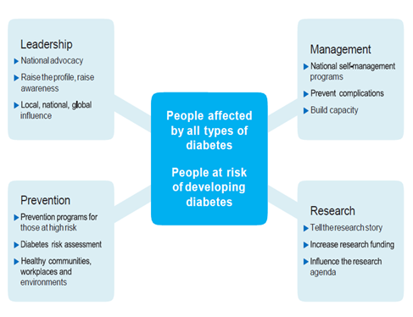

- Summary of Findings
  - Diabetes as a Chronic Condition
Diabetes is a chronic condition marked by high levels of glucose in the blood. It is caused either by the inability to produce insulin (a hormone produced by the pancreas to control blood glucose levels), by the body not being able to use insulin effectively, or both.
The main types of diabetes are:

Type 1 diabetes:
- A lifelong autoimmune condition that causes the immune system to destroy cells in the pancreas that produce insulin. It usually has onset in childhood or early adulthood but can occur at any age. There is no cure and people with type 1 diabetes require daily treatment with insulin for survival.
Type 2 diabetes:
- The most common form of diabetes, and is largely preventable, as it is often associated with lifestyle factors. Insulin production by the pancreas becomes progressively slower and key organs in the body become resistant to the effects of insulin (which means that they are less able to utilise glucose from the blood).
Gestational diabetes:
- Initially occurs during pregnancy and usually disappears following the birth of the baby, although women who have had gestational diabetes are at significant risk of subsequently developing other types of diabetes.
Diabetes represents one of the most challenging public health problems of the 21st century and is reaching epidemic levels globally. It still continues to remain under-reported, partly because many people with type 2 diabetes do not realise they have it and do not seek help until they have developed complications, which may be many years after diabetes actually began. (Baker IDI Heart and Diabetes Institute, 2012, p. 15).
It has been estimated that, in Australia, for every five diagnosed cases of diabetes, there are four undiagnosed cases (Baker IDI Heart and Diabetes Institute, 2012, p. 15). If left unchecked, 1 in 14 adults or an estimated 380 million people worldwide are predicted to have diabetes by 2025. (AIHW, 2008)
Diabetes can result in a range of short- and long-term complications which are the major causes of associated morbidity and mortality in people with diabetes. The presence of complications also greatly increases the cost of managing diabetes. Improving the management and care of diabetes, particularly the early identification and reduction of risk factors, can delay the onset or slow the progression of complications.
  - How common is diabetes?
According to the ABS National Health Survey (2014-15), 1 in 17 Australian adults, which is approximately 1.2 million people, in 2014–15 had diabetes, based on self-reported data.
The majority of these (85%) had type 2 diabetes and 15% had type 1 diabetes. (Australian Bureau Statistics, 2014-15).
Gestational diabetes is also becoming more common in Australia, between 5% and 10% of pregnant women will develop gestational diabetes (Diabetes Australia, website - May 2017).

Prevalence
Prevalence is the number of people with diabetes at a point in time. According to the ABS 2014–15 National Health Survey, an estimated 1.2 million (5.1%) people in Australia had diabetes, an increase from 4.5% in 2011-12.
In Tasmania, an estimated 26,600 (5.3%) people had type 1 or type 2 diabetes, or an unknown (other) type of diabetes in 2014-15. (Australian Bureau Statistics, 2014-15). The prevalence of diabetes in Tasmania has increased by almost one percent since 2011/12, but the gap between the Tasmanian and the national rate of diabetes has narrowed in 2014/15. The prevalence of type I diabetes in 2011/12 was 0.5%. Rates for type 1 diabetes for 2014/15 have not been published.
Graph 1: Prevalence of self-reported diabetes*, Tasmania and Australia 2011/12 and 2014/15
(ABS, National Health Survey 2014/5, State Tables; ABS, Australian Health Survey 2011/12)

*includes type 1 and 2 and type unknown.
The prevalence of diabetes is higher among males (5.8%) than females (4.7%) and higher among older age groups with about one in six Tasmanians (17.1%) aged 65 years and over reporting diabetes.
Graph 2: Prevalence of self-reported diabetes*, Tasmania 2014/15
(ABS, National Health Survey 2014/5, State Tables)

*includes type 1 and 2 and type unknown.
A total of 3,523 females and 4,131 males were dispensed a Pharmaceutical Benefits Scheme (PBS) prescription for insulin in 2014-15, with almost a quarter of all prescriptions (24.2%) dispensed to Tasmanians aged 60-69 years.
Graph 3: Number of patients * with PBS insulin prescriptions by age and gender, Tasmania 2014-15
(AIHW, MBS and PBS use for diabetic care, states and territories, 2014-15 (unpublished data))

*The total number of unique patients who were dispensed a PBS prescription for insulin.
The Australian Health Policy Collaboration “Australia’s Health Tracker by Area” website provides the most up to date Australian data on chronic conditions and their risk factors. http://www.atlasesaustralia.com.au/ahpc/. The below table provides a breakdown of the estimated diabetes prevalence for the age group 25-64 years for 2014-2015 in Tasmania by LGA.
Table 1: Estimated prevalence of diabetes for Tasmanians aged 25-64 years by LGA, 2014-2015
(http://www.atlasesaustralia.com.au/ahpc/data.html -accessed August 2017)
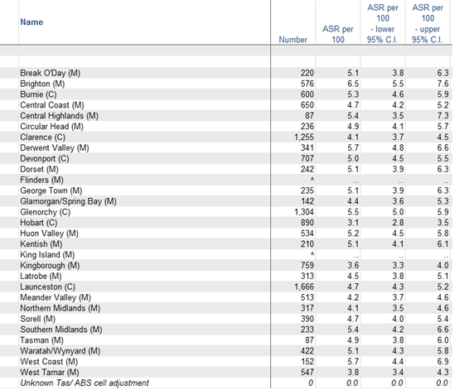
Number  95% C.I. | The numbers are estimates for an area, not measured events  upper and lower 95% confidence intervals
ASR | indirectly age-standardised rate per 100 population

Trends
The prevalence of diabetes (based on self-reported data) has tripled between 1989–90 and 2014–15 where the proportion of people with diabetes has increased from 1.5% to 4.7%. (AIHW - website, National Health Survey 2014-15)

Inequalities - remoteness and socioeconomics
The prevalence of diabetes risk factors such as overweight and obesity, and physical inactivity is higher in groups with lower socioeconomic position compared with groups with higher socioeconomic position.

In 2014–15, the prevalence of diabetes among adults was similar by remoteness but varied by socioeconomic disadvantage. (AIHW, 2016)

Compared with those living in Major cities, people in combined Remote and Very remote areas were:
- 1.8 times as likely to be hospitalised for diabetes
- 1.9 times as likely to die from diabetes.

Compared with those living in the highest socioeconomic areas, people living in the lowest socioeconomic areas were:
- 3.6 times as likely to have diabetes
- 1.8 times as likely to be hospitalised for diabetes
- 2.0 times as likely to die from diabetes.

Diabetes Registrations
The current rate of registrations with the National Diabetes Services Scheme (NDSS) for Tasmania is 5.4%, increasing to 13.6% for those aged 60 years. The prevalence in Tasmania, is an estimated 5.3% people with 17.1% aged 65 years and over reporting diabetes.
More males are registered with the NDSS than females (5.7% compared to 5.1%).
Of all persons diagnosed with diabetes and registered with the NDSS, those registered with type 2 diabetes are the most common.
Table 2: Diabetes registrations* by type and gender, Tasmania 2017
(National Diabetes Services Scheme (NDSS) 2017; http://www.diabetesmap.com.au/#/ - accessed August 2017)
 | Type 1 Diabetes | Type 2 Diabetes | Gestational and other types of diabetes | Total diabetes
Persons | 0.6% | 4.6% | 0.2% | 5.4%
Females | 0.5% # | 4.4% # | 0.2% # | 5.1%
Males | 0.5% # | 4.9% # | 0.3% # | 5.7%
60 years and over | n/a | n/a | n/a | 13.6%
*Tasmanians diagnosed with diabetes and voluntarily registered with the NDSS
#rates by gender are estimates derived from population estimates provided on the NDSS database

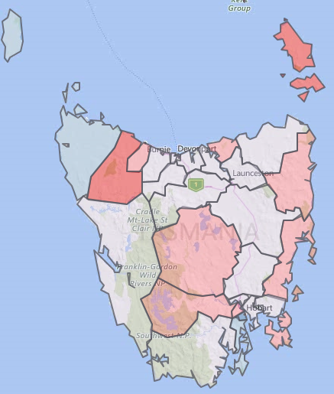
The data contained in the Australian Diabetes Map is derived from the National Diabetes Services Scheme (NDSS) Registrant database and the Australian Bureau of Statistics (ABS) and shows people diagnosed with diabetes that are registered on the Scheme.
To access the map for further information, click here: https://www.ndss.com.au/diabetes-map
The map reflects diabetes prevalence rates at a national, federal, state electorate, local government, primary health network, and postcode level based on NDSS data and ABS 2012-2101 population projections. It shows the numbers of people diagnosed with diabetes in all parts of Australia with information on age, gender, type of diabetes, ATSI status and socio-economic disadvantage.

Incidence
Incidence is the number of new cases of diabetes during a period of time.
- Type 1 diabetes incidence rates remained relatively stable in Australia between 2000–2014, fluctuating between 11 and 13 new cases per 100,000 population each year (in 2014, the rate was 11 per 100,000 population).
- In 2015, the incidence rate of type 1 diabetes was higher in males than females (13 compared with 10 per 100,000 population); and
- Almost 2 in 3 (63%) new cases of type 1 diabetes were among children and young people under 25 years.
Note, nationally there is currently no updated data available on the incidence of type 2 diabetes. (AIHW - website, National Health Survey 2014-15)
In 2011, the incidence rate of diabetes was 4.9% for the Tasmanian population, rising to 14% for Tasmanians aged 60 years and over. Males were generally more likely to be diagnosed with diabetes than females (5.2% compared to 4.7%). Of the cases notified to the National Diabetes Register, type 2 diabetes remains by far the dominant type. (DHHS, 2013)
Table 3: Diabetes incidence rate by type and gender, Tasmania 2011
(National Diabetes Register, Australia (unpublished data))
 | Total Population |  | 60 years and over
Female | % | 95% CI | % | 95% CI
Type 1 | 0.6% | [0.5%,0.6%] | 0.9% | [0.8%,1%]
Type 2 | 3.9% | [3.8%,4%] | 11.3% | [11%,11.6%]
Total Diabetes | 4.7% | [4.6%,4.7%] | 12.3% | [12%,12.6%]
Male
Type 1 | 0.7% | [0.6%,0.7%] | 1.2% | [1.1%,1.3%]
Type 2 | 4.5% | [4.4%,4.6%] | 14.7% | [14.4%,15%]
Total Diabetes | 5.2% | [5.1%,5.3%] | 16.0% | [15.7%,16.3%]
Persons
Type 1 | 0.6% | [0.6%,0.6%] | 1.1% | [1%,1.1%]
Type 2 | 4.2% | [4.2%,4.3%] | 12.9% | [12.7%,13.1%]
Total Diabetes | 4.9% | [4.9%,5%] | 14.0% | [13.8%,14.2%]

  - Risk Factors
Health risk factors are attributes, characteristics or exposures that increase the likelihood of a person developing a disease or health disorder. In addition to affecting the development of disease, health risk factors can also affect the progression and treatment outcomes of diseases and other health conditions. For further information please refer to the DHHS – Acute Strategy SoPI 2018-19 Supplementary Paper 11: “Chronic Disease: Risk Factors: Research and Discussion Paper”.
It should be highlighted that type 2 diabetes is largely preventable. A number of factors are known to increase the risk of developing diabetes, particularly type 2 diabetes, including behavioural and biomedical risk factors. The control of modifiable risk factors, such as overweight and obesity and physical inactivity, are central to preventing type 2 diabetes and can help reduce the complications associated with diabetes.
Behavioural risk factors are those that individuals have the most ability to modify. The below behavioural risk factors are known to increase the risk of developing diabetes. (AIHW, 2015).
Excessive alcohol consumption
In 2011–12, 11% of adults with diabetes consumed more than 2 standard drinks per day on average, exceeding lifetime alcohol risk guidelines. Among the population without diabetes, 19% exceeded alcohol guidelines.
Tobacco smoking
People with type 1 and type 2 diabetes who smoke are at an increased risk of developing complications such as CHD, stroke, peripheral vascular disease and CKD. In 2011–12, 12% of adults with diabetes were daily smokers, a similar proportion to that among adults without diabetes (11%).

Diabetes Behavioural
risk factors

Inadequate fruit and vegetable
consumption
Poor diet is a risk factor for type 2 and gestational diabetes largely through its influence on body weight, and particularly obesity. In 2011–12, 94% of adults with diabetes did not consume the recommended amounts of fruit and vegetables in their diets.
Insufficient physical activity
Participation in physical activity can reduce the risk of developing type 2 diabetes and reduce diabetes-related mortality. In 2011–12, 70% of persons with diabetes were inactive or insufficiently active, compared with 52% of persons without diabetes.

The comparison of behavioural risk factors between persons aged 18 years and over, with and without diabetes is also presented below.
Graph 5: Behavioural risk factors, persons aged 18 and over, with and without diabetes 2011-12
(AIHW, 2015 ‘Cardiovascular Disease, diabetes and chronic kidney disease, Australian facts – Risk Factors, pp47)
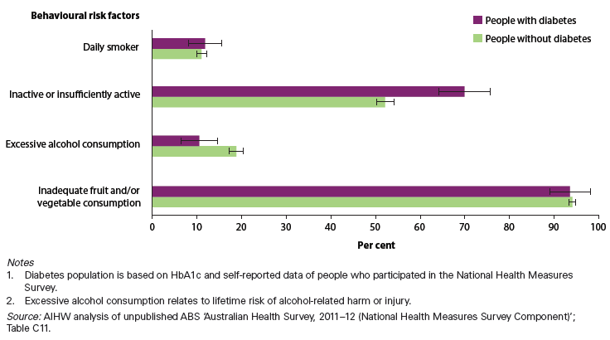

Biomedical risk factors are bodily states that can contribute to the development of chronic disease and are often influenced by behavioural risk factors. The below biomedical risk factors are known to increase the risk of developing diabetes. (AIHW, 2015).
Dyslipidaemia
The characteristic features of diabetic dyslipidaemia are high levels of triglycerides, low HDL cholesterol and increases in small, dense LDL cholesterol particles, resulting from insulin resistance and deficiency. In 2011–12, 86% of adults with diabetes had dyslipidaemia, of whom 67% had uncontrolled dyslipidaemia, compared with 62% and 56% respectively for those without diabetes.

Overweight and obesity
Overweight and obesity is an important modifiable risk factor for type 2 diabetes. In 2011–12, 88% of people with diabetes were overweight or obese. The proportion of persons with diabetes who were overweight or obese was 1.5 times that of persons without diabetes (59%). The gap was larger for obesity alone; the proportion of persons with diabetes who were obese was 2.4 times that of persons without diabetes.

Diabetes
Biomedical
risk factors

High blood pressure
High blood pressure contributes to the development of diabetes complications. In 2011–12, 77% of people aged 18 and over with diabetes had high blood pressure. This proportion is substantially higher than for those without diabetes (27%). Similarly, the proportion of persons with diabetes who had uncontrolled high blood pressure (38%) was double that of persons without diabetes (19%).

The comparison of the biomedical risk factors between persons aged 18 years and over, with and without diabetes is presented below.
Graph 6: Biomedical risk factors, persons aged 18 and over, with and without diabetes, 2011-12
(AIHW, 2015 ‘Cardiovascular Disease, diabetes and chronic kidney disease, Australian facts – Risk Factors, pp50)
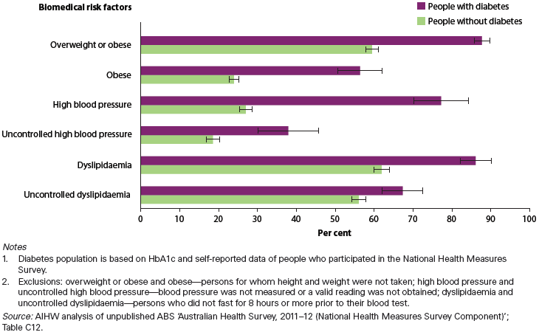

  - Prevention
International evidence shows type 2 diabetes can be prevented or delayed in up to 58% of cases by maintaining a healthy weight, being physically active and following a healthy eating plan. (Diabetes Australia, website - May 2017)
People at risk of type 2 diabetes can delay and even prevent the condition by:
- Maintaining a healthy weight
- Regular physical activity
- Making healthy food choices
- Managing blood pressure
- Managing cholesterol levels
- Not smoking.
Unfortunately type 1 diabetes cannot currently be prevented. Research into the autoimmune process and risk factors that lead to developing type 1 diabetes may be able to prevent type 1 diabetes in the future. (Diabetes Australia, website - May 2017)
  - Burden of the Disease
In 2011, diabetes accounted for 2.3% of the total burden of diseases and injuries in Australia (AIHW, 2016)
The below figure: ‘Leading causes of total burden’ highlights diabetes as the leading cause of total burden for males aged between 65-74 years and females aged 85+ years.
Figure 3: AIHW ‘Leading causes of total burden, by age and sex, 2011’
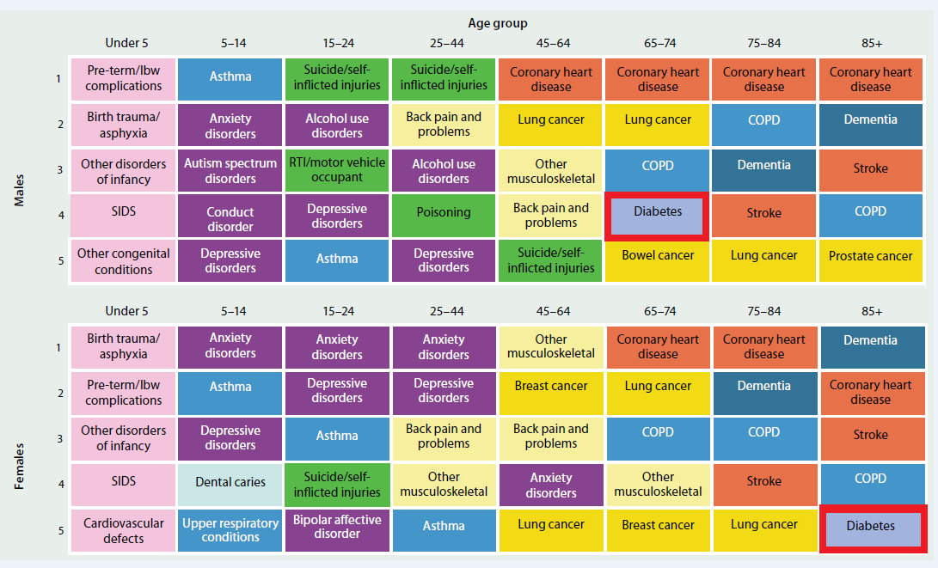

The table below shows disability adjusted life years (DALYs) for disease groups based on the 2011 Burden of Disease Study. Diabetes makes up a sizable proportion of endocrine disorders, which constitute 2.6% of the total disease burden in Tasmania, and is one of the top ten disease burdens in Tasmania and nationally.
Table 4: Differentials in disease burden (DALYs) in Tasmania for the 10 leading disease groups, 2011
(AIHW Australian Burden of Disease 2011, released August 2016)

 | Number | % DALYs | % DALYs Australia
Cancer & other neoplasms | 23,519 | 20.0% | 18.5%
Cardiovascular diseases | 17,458 | 14.8% | 14.6%
Musculoskeletal conditions | 15,262 | 13.0% | 11.6%
Respiratory diseases | 10,562 | 9.0% | 8.3%
Mental & substance use disorders | 9,867 | 8.4% | 12.1%
Injuries | 9,333 | 7.9% | 8.8%
Neurological conditions | 9,222 | 7.8% | 6.8%
Gastrointestinal diseases | 3,470 | 3.0% | 3.2%
Endocrine disorders (includes diabetes) | 3,088 | 2.6% | 2.4%
Oral disorders | 2,980 | 2.5% | 2.2%

The National Diabetes Strategy and Action Plan figure below shows that macrovascular complications of diabetes (heart disease, stroke, peripheral vascular disease) may begin even before people develop diabetes. The microvascular complications (eye, kidney and nerve damage) begin when diabetes develops but many people will have complications when they are diagnosed because of a delay in diagnosis. In order to reduce the diabetes burden, a comprehensive strategy must prevent the development of diabetes, detect those with undiagnosed diabetes earlier, and improve the care for those with diabetes to prevent complications.
Figure 4: Preventing the Diabetes Burden
(Diabetes Australia – National Diabetes Strategy and Action Plan, 2013)
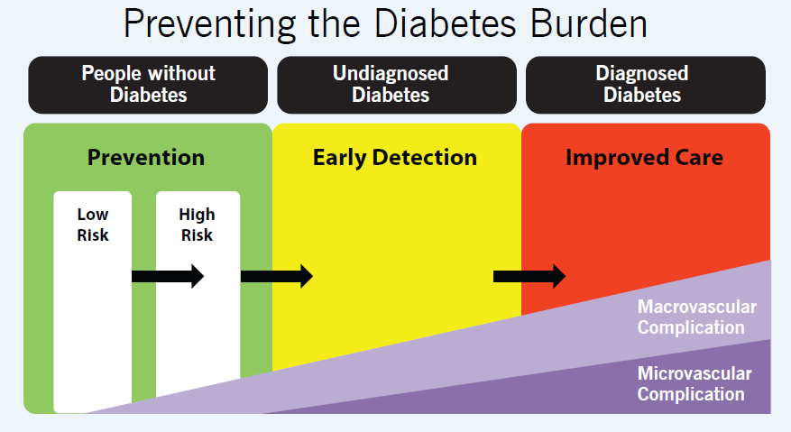
  - Co-morbidity
Diabetes may increase the risk of complications, including heart disease, stroke, kidney disease, retinopathy (loss of vision), heart failure and limb amputation.
Diabetes is also commonly associated with other causes of death, in particular for deaths involving chronic and unspecified kidney failure, coronary heart disease (CHD), and asthma.
The proportion of disease burden that is attributable to diabetes was estimated for each associated disease as per figure below. This is derived from the number of DALY attributable to diabetes divided by the direct burden of each linked disease. (AIHW, Aust Burden of Disease Study 2011)
Graph 7: Proportion of burden attributable to diabetes, by linked disease and sex, 2011
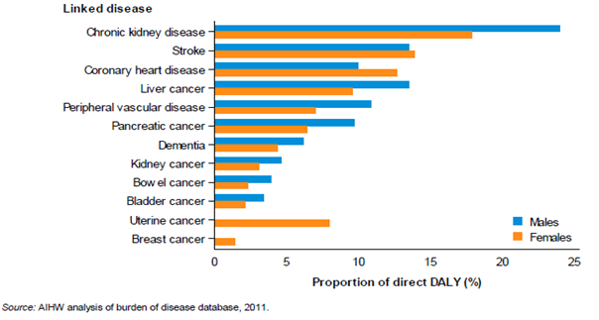
In the Australia Burden of Disease Study (ABDS) 2011, the direct burden of diseases linked with diabetes was predominantly fatal, with the exception of dementia burden, where it was mainly non-fatal. This influenced the proportion of fatal and non-fatal outcomes for the indirect diabetes burden.
Graph 8: Proportion of indirect diabetes burden, by linked disease due to fatal and non-fatal outcomes, 2011
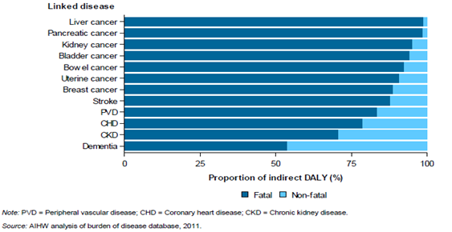
  - Hospitalisations
People with diabetes, particularly those with complications, are likely to experience episodes of hospitalisation.
There were over 1 million hospitalisations where diabetes as the principal
and/or additional diagnosis in 2014–15 was recorded,
according to the AIHW National Hospital Morbidity Database.

In 2014–15, nationally there were approximately:
It is more likely that a patient hospitalised with a complication due to diabetes will be coded for the complication as the primary/principal diagnosis rather than the actual diabetes condition. Diabetes may (or may not) appear as a secondary/additional diagnosis. Further work needs to be undertaken to understand the coded data environment before purchasing actions related to diabetes can be formulated. (SoPI 2017/18)
Tasmanian admitted patient public hospital separations from 1 July 2011to 30 June 2016 by ABS Statistical Area (SA) 3 region and by type of diabetes, for separations with diabetes as a primary diagnosis only are shown below.
Figure 5: Tasmanian admitted patient public hospital separations by diabetes type
(Public hospital admitted patients: All Diabetes Types; Primary Health Tasmania 2017)
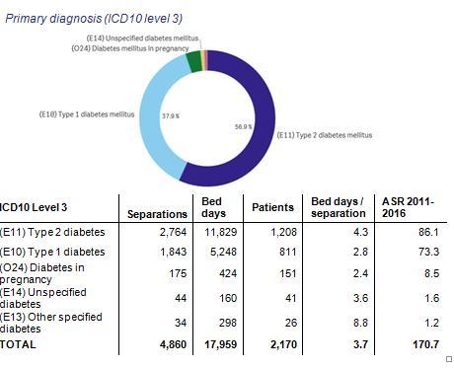
Tasmanian admitted patient public hospital separations by patient region from 1 July 2011 to 30 June 2016 by SA3 region, for separations with all types of diabetes as a primary diagnosis only are shown below.
Figure 6: Tasmanian admitted patient public hospital separations by patient region
(Public hospital admitted patients: All Diabetes Types; Primary Health Tasmania 2017)
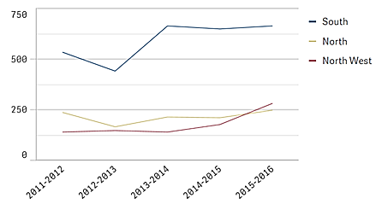

Average Length of Stay
The average length of stay for hospitalisations where diabetes was recorded in Australia was:
Type 1 diabetes
- Principal diagnosis was 4.3 days.
- Additional diagnosis was 6.4 days.
Type 2 diabetes
- Principal diagnosis was 8.6 days.
- Additional diagnosis was 7.4 days.
(people who are admitted and separated on the same date were excluded)
In Tasmania, the average length of stay for hospitalisations where diabetes was recorded during 2017 was:
Type 1 diabetes
- Principal diagnosis was 3.2 days.
Type 2 diabetes
- Principal diagnosis was 5 days.
Other types diabetes (including gestational)
- Principal diagnosis was 2.6 days.
All Diabetes types
- Additional diagnosis was 4.12 days.
The average length of stay in hospital increases with increasing age, with older people having longer lengths of stay in hospital with the principal or an additional diagnosis of diabetes. (AIHW - website, 2014)

Potentially preventable hospitalisations
Over the period 2015-16, there were 13,670 potentially preventable hospitalisations in Tasmania, representing 6.3% of all hospitalisations (all causes combined).
Among the top potentially preventable hospitalisations in Tasmania are diabetes complications, which made up 9.2% of all potentially preventable hospitalisations in 2015-16.
The number of potentially preventable hospitalisations for diabetes complication has fallen from 1,357 in 2010-11 to 1,265 in 2015-16, representing a reduction of 6.8% over the last five years.
Graph 9: Potentially preventable hospitalisations by type of condition, Tasmania, 2015-16
(AIHW, Australian hospital statistics 2015-16, Table 4.23, June 2017)

The Second Australian Atlas of Healthcare Variation (ACSQHC, 2017) data examines hospitalisations for diabetes complications in people of all ages based on patient place of residence. Long-term complications of diabetes include stroke, heart disease, kidney disease, eye disease, nerve problems and foot ulcers. Short-term complications include diabetic ketoacidosis. The below data includes hospitalisations for type 1 diabetes, type 2 diabetes, and other or unspecified diabetes, as well as hospitalisations with diabetes complications as the primary diagnosis and dialysis as an additional diagnosis are included.
Tasmania’s rate (190) of potentially preventable hospitalisations for diabetes complications is slightly above the Australian rate (173) as presented in the figure below. Sorell-Dodges Ferry area (SA3) has the highest rate for Tasmania at 333 with the lowest rate of 86 in the Meander Valley-West Tamar area (SA3).

Figure 7: Number of potentially preventable hospitalisations – diabetes complications per 100,000 people, age and sex standardised, by Statistical Area Level 3 (SA3), state and territory, 2014–15
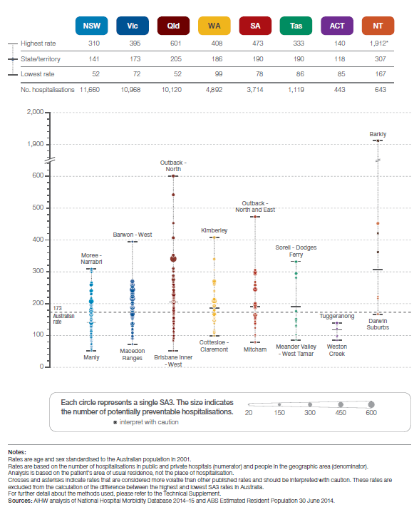
  - Mortality
Diabetes contributed to 10% of all Australian deaths in 2014 which is over 15,700 deaths, according to the AIHW National Mortality Database. (AIHW - website, 2014). Diabetes was the underlying cause of death in around 4,300 deaths (28% of diabetes deaths), and an associated cause of death in a further 11,400 deaths (72% of diabetes deaths).
However, diabetes is far more likely to be listed as an associated cause of death. This is because it is often not diabetes itself that leads directly to death but one of its complications that will be listed as the underlying cause of death on the death certificate.

Australia and Tasmania comparison
The Tasmanian age-standardised mortality rate for diabetes in 2015 was higher than for Australia.
Graph 10: Age standardised mortality rate per 100,000 population for diabetes mellitus* (ICD-10, E10-E14), Tasmania and Australia 2015
(‘Causes of Death Australia 2015’, September 2016)

*based on underlying cause of death.

Tasmania comparison by region
For the five year period from 2008 to 2012, the southern region had the lowest mortality rates of all regions in Tasmania. In comparison with other regions, the southern region had a statistically significant higher rate for males (26.2 per 100,000) compared with females (16.2 per 100,000 population).
Graph 11: Age-standardised mortality rates for diabetes (ICD-10, E10-E14) by region Tasmania 2008-12
(DHHS, EPI Unit unpublished data)

Note: ASR are standardised with the Australian 2001 population and expressed per 100,000 persons years.
Note: Number of 'persons' may exceed the sum of males and females due to the inclusion of those with an unknown gender.

Tasmania mortality rate by age group
Deaths caused by type one and type two diabetes are uncommon for persons under the age of 65 years.
Graph 12: Mortality rate per 100,000 population for diabetes mellitus (ICD-10, E10-E14) by age group, Tasmania 2015
(‘Causes of Death Australia 2015’, September 2016)

*based on underlying cause of death.
  - Discussion

Diabetes - Management
Diabetes is a chronic condition requiring the use of a variety of health services for its control and for the early diagnosis and treatment of associated complications. To better manage diabetes, people with diabetes use a range of health services to control blood sugar, blood pressure and blood lipid levels to reduce symptoms and the risk of complications, and to enhance their quality of life. Having complications as well as diabetes greatly increases the use of health services. People without diabetes who have a number of diabetes risk factors are also likely to use more health resources (AIHW, 2008)
The aims of diabetes management are:
- Remove the symptoms and short-term risks of high blood glucose
- Prevent longer term complications
- Detect and treat any complications early if they do arise.

For both type 1 and type 2 diabetes, together with medication, a degree of blood glucose control can be brought about through lifestyle approaches, such as a healthy diet, regular exercise and resulting weight control. Avoiding smoking and maintaining good control of blood pressure and blood cholesterol levels as well as the lifestyle approaches help reduce the risk of complications such as heart attack and stroke.
GPs are usually the initial point of contact for people with diabetes and play a key role in coordinating the services that are needed because the condition and its complications affect several parts of the body. Patients and their carers also need information and support. Thus, a range of other health professionals may also be involved.
The Tasmanian HealthPathways (THP) developed by Primary Health Tasmania (PHT) provides a pathways program that gives health professional’s access to a single website that:
- provides information on how to assess and manage a wide range of health conditions, and
- how to refer patients to local specialists and services in the most timely and efficient way.
THPs have a number of Diabetes pathways on the website, including screening and diagnosis through to management.

Diabetes Centres
Within the Tasmanian public health system, the acute hospital inpatient and outpatient environment, there are designated Diabetes Centre accredited by the National Association of Diabetes Centre (NADC).
In accordance with the Tasmanian Role Delineation Framework (TRDF) and Clinical Services Profile (CSP) described within the Endocrinology Service Profile Framework, a Diabetes Centre provides inpatient care as well as ambulatory (outpatient) multidisciplinary care for individuals with a clinical diagnosis of diabetes. The Centre aims to bridge the gap between acute hospital care and primary care within the community, including the prevention of hospitalisation.
The primary role of the Diabetes Centre is to optimise health outcomes for people with diabetes by reducing hospital lengths of stay, supporting outpatient flow to transition patients back into the community, and initiation of hospital avoidance strategies where possible.

- Diabetes – Future Purchasing Strategies
Further monitoring and surveillance of diabetes is crucial for guiding preventive measures, determining clinical care and informing health policy and service planning. Diabetes has a significant impact on Australia’s health and productivity. Research efforts need to be focused on strengthening evidence-based practice for the prevention of diabetes and its complications, identifying a cure for diabetes, informing health policy decisions and potentially offering more timely access to newer and improved medications.
The below figure represents high level purchasing strategies that could be considered by the service provider and service delivery planners in collaboration with all health sectors, including acute, community and primary care:
Figure 8: Diabetes Future Purchasing Strategies
Prevention | - Continue to implement community awareness and health literacy programs to enhance healthy eating, increase physical activity and improve knowledge of diabetes risk factors.  - Develop a strategy and set of diabetes guidelines for prevention of type 2 diabetes, including the reduction of hospitalisations for diabetes and related complications.  - Develop statewide integrated Models of Care to assist in reducing diabetes complications
Early Detection | - Promote awareness by establishing programs and information sessions to understand the early detection and symptoms of Diabetes and associated complications.  - Expand targeted risk assessment and screening opportunities in a range of healthcare settings.
Intervention | - Establishing specific interventions to assist in reducing complications for diabetes; including point-of-care testing for HbA1c, which has been suggested as a strategy to facilitate earlier diagnosis of diabetes.  - Developed guidelines to identify the early symptoms of type 2 diabetes, as it is often absent in the early stages and so people can go undiagnosed for a long period of time.
Self-management and Education | - Encourage and promote the management and care of diabetes through intensive self-management to prevent complications, by referring patients to health care pathways for diabetes.  - Continue to develop and implement accessible self-management and peer support programs for people with diabetes and their carers in various settings, in particular people living in rural and remote areas.  - Continue to implement coordinated, multidisciplinary and streamlined care for people with diabetes, particularly for those with chronic and complex conditions

Works Cited
ACSQHC, 2017. The Second Australian Atlas of Healthcare Variation, s.l.: s.n.
AIHW - website, 2014. Deaths from diabetes, s.l.: s.n.
AIHW - website, 2014. Hospital Care for diabetes, s.l.: s.n.
AIHW - website, National Health Survey 2014-15. Diabetes Indicators, s.l.: s.n.
AIHW - website, National Health Survey 2014-15. How many Australians have diabetes?, s.l.: s.n.
AIHW, 2008. Diabetes Australian Facts, s.l.: s.n.
AIHW, 2011. Impact and Causes of Illness and Death in Australia, Canberra: Australian Government.
AIHW, 2014-15. ABS Microdata: National Health Survey, s.l.: s.n.
AIHW, 2015. Cardiovascular Disease, diabetes and chronic kidney disease, Australian facts, risk factors, s.l.: s.n.
AIHW, 2016. Australia's Health, s.l.: s.n.
AIHW, Aust Burden of Disease Study 2011. Diabetes and CKD as risks for other diseases, s.l.: s.n.
Australian Bureau Statistics, 2014-15. National Health Survey, s.l.: s.n.
Baker IDI Heart and Diabetes Institute, 2012. Diabetes: the silent pandemic and it's impact on Australia, s.l.: s.n.
Department of Health, Aust Govt, 2015. Australian National Diabetes Strategy 2016-2020, s.l.: s.n.
DHHS, 2013. Health Indicators - Tasmania 2013, Hobart: Department of Health and Human Services.
Diabetes Australia, website - May 2017. About Diabetes - prevention, s.l.: s.n.
Diabetes, Australia, 2013-2018. Strategic Plan, s.l.: s.n.

As reflected in the Tasmanian Health Organisations Act 2011 section 3 http://www.austlii.edu.au/au/legis/tas/num_act/thoa201151o2011346/s3.html

